Building a Kubernetes Cluster on AWS with Kops (Kubernetes Operations)
— Hands-On DevOps Practice
I recently worked through the end-to-end process of provisioning a Kubernetes cluster on AWS using Kops, reinforcing my practical understanding of Kubernetes infrastructure, AWS services, IAM, networking, and cluster administration.
Here’s a high-level walkthrough of the implementation:

1. Prepare the AWS Environment
I created an EC2 instance to serve as the administration server for deploying and managing the Kubernetes cluster.
I also configured:
IAM User & Permissions
- Created an IAM user for Kops
- Assigned the required AWS permissions
- Generated an Access Key and Secret Access Key
- Configured AWS CLI credentials on the server
SSH Authentication
After connecting to the EC2 instance through SSH, I generated an SSH key pair:
ssh-keygen

2. Install AWS CLI
Installed and configured the AWS CLI so the server could interact with AWS resources.
aws configure

3. Install Kops
Downloaded the latest Kops binary:
curl -Lo kops https://github.com/kubernetes/kops/releases/download/$(curl -s https://api.github.com/repos/kubernetes/kops/releases/latest | grep tag_name | cut -d '"' -f 4)/kops-linux-amd64
Made it executable:
chmod +x kops
sudo mv kops /usr/local/bin/kops
Verified the installation:
kops version

4. Install kubectl
Installed kubectl to interact with the Kubernetes cluster:
curl -LO https://dl.k8s.io/release/$(curl -L -s https://dl.k8s.io/release/stable.txt)/bin/linux/amd64/kubectl
Then installed it into the system path:
sudo install -o root -g root -m 0755 kubectl /usr/local/bin/kubectl
Verify:
kubectl version --client

5. Configure S3 & Route 53
Back in the AWS environment, I configured:
Amazon S3 — to store the Kops cluster state.
Amazon Route 53 — created a hosted zone to provide DNS management for the Kubernetes cluster.

6. Create the Kubernetes Cluster
With the infrastructure ready, I created the cluster:
kops create cluster \
--name=<YOUR_HOSTED_NAME> \
--state=s3://<YOUR_S3_BUCKET> \
--zones=us-east-1a,us-east-1b \
--node-count=2 \
--node-size=t3.small \
--control-plane-size=t3.medium \
--dns-zone=<YOUR_HOSTED_NAME> \
--node-volume-size=12 \
--control-plane-volume-size=12 \
--ssh-public-key ~/.ssh/id_ed25519.pub
Then applied the cluster configuration:
kops update cluster \
--name=<YOUR_HOSTED_NAME> \
--state=s3://<YOUR_S3_BUCKET> \
--yes \
--admin

7. Validate the Cluster
After allowing approximately 15 minutes for AWS resources and Kubernetes components to initialize, I validated the cluster:
kops validate cluster \
--name=<YOUR_HOSTED_NAME> \
--state=s3://<YOUR_S3_BUCKET>
Finally, I confirmed the Kubernetes nodes:
kubectl get nodes
Cluster up and running!
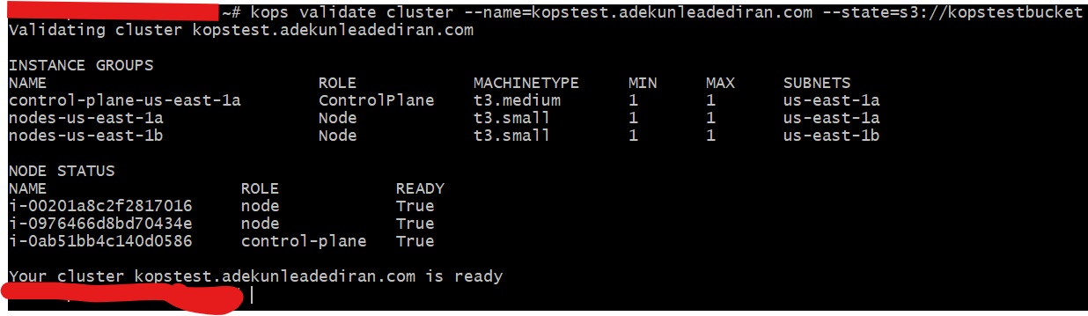
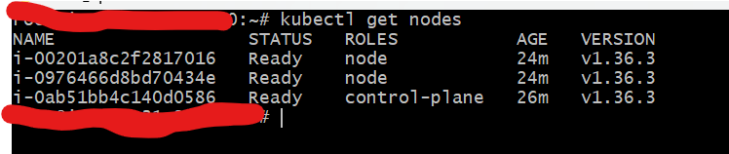
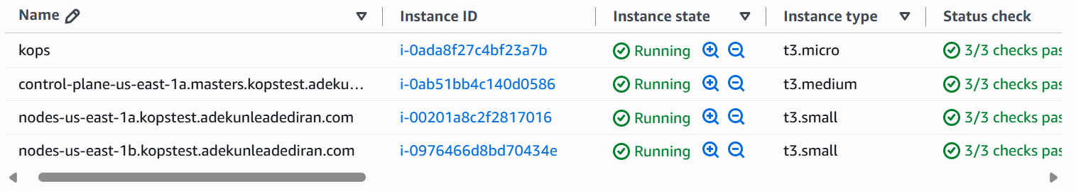
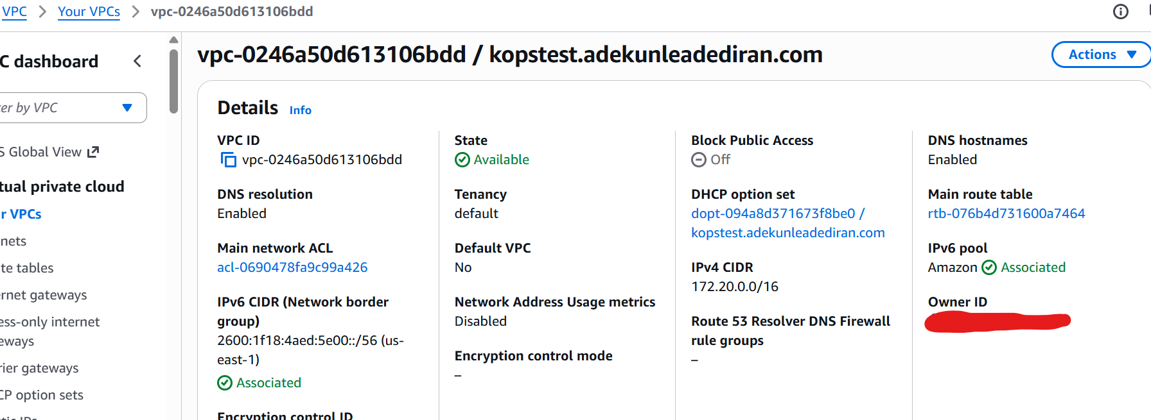
This exercise provided valuable hands-on experience across several important DevOps areas:
AWS EC2 | IAM | S3 | Route 53 | AWS CLI | Linux | SSH | Kops | Kubernetes | kubectl | Cloud Infrastructure
What I particularly appreciate about Kops is how it brings together multiple infrastructure components required for a production-style Kubernetes environment while still giving you visibility and control over the underlying AWS resources.
Every hands-on deployment strengthens the connection between cloud infrastructure, networking, security, automation, and Kubernetes administration.

I am available for production ready collaboration, start-ups and remote jobs opportunity
#DevOps #Kubernetes #AWS #Kops #CloudComputing #AWSCloud #Infrastructure #CloudEngineering #DevOpsEngineer #Linux #Kubectl #LearningByDoing

